Birkbeck: Modern Statistical Methods

Assessed Coursework 2012-2013

This task describes a simplified model that relates to some of the issues faced by insurance companies.

Suppose a small insurance company has current assets of £250000. They have 1000 custo mers who are each charged an annual premium of £6000, paid at the start of the year. Based on previous experience, it has been estimated that the probability of a customer making a claim is 0.1 in any year, independently of previous claims and other customers. The size X of a claim varies, and is believed to have the following density function:

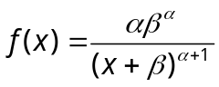 for x ≥ 0,

f(x) = 0 for x < 0.

Such an X is said to have a Pareto distribution. It has been used in practice to describe the size of an insurance claim.

We consider the fortunes of the insurance company over the coming year, and in particular, the risk of bankruptcy, which occurs if assets drop below zero. Assume that no customer makes more than one claim in a year.

Question 1: simulating X

Let X be the size of a typical claim as described above.

- Calculate the cumulative distribution function F(x) of X, the expectation E(X) and the variance var(X). State any conditions on α and/or β that need to be satisfied.

All done in the pad!

b) Describe a method to simulate from X.

Now assume α = 3, β = 100,000. These values will be fixed for the remainder of the assignment, unless you choose to alter them.

c) Provide code in R to simulate 1000 values drawn from X. You may only use basic R commands, not any preset routines to simulate from a Pareto distribution. Produce a histogram of these values, with the true density function superimposed.

R code:

Nsim=10^3
#number of random numbers

a<-3
b<-100000

U=runif(Nsim)
x=((b^a)/(1-U))^(1/a)-b

#plot the histogram
hist(x,freq=FALSE,col="grey",main="Parento from Uniform")

#Now plt the curve on top

curve((a*b^a)/((x+b)^(a+1)), col = 2, add = TRUE)

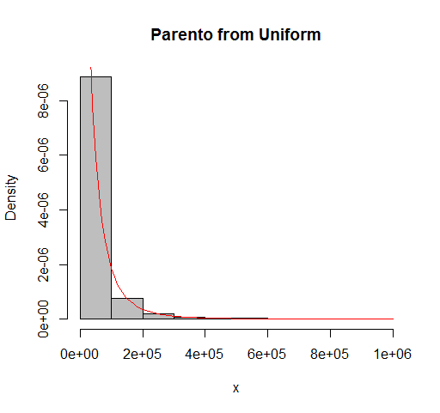

Question 2: simulating year end results

Write a function to simulate the assets of the company at year end. From your simulation, find the expected assets at year end and the probability that the company goes bankrupt.

Question 3: changing inputs

a) Repeat question 2 for annual premiums £5550, £5750, £6000, …., £8000. Plot a graph showing how the probability of bankruptcy varies with annual premium. All else being equal, at what level should the premium be set if the risk of bankruptcy should be no more than 2%?

b) Repeat question 2 when the probabilities of any customer making a claim are 0.05, 0.055, 0.06, …., 0.15. Plot a graph showing how the probability of bankruptcy varies with the probability of making a claim.

Question 4: report writing

Assume you have been acting as consultant to the company. Write a short report (maximum 750 words) of your findings. Since it will be considered by the board of the company, you should avoid technical details as much as possible. You need not substantially repeat any information from questions 1 to 3, but you should:

a) State any assumptions you have made;

b) Provide any advice you can on factors the company may be able to control;

c) Indicate any reservations you have;

d) Provide brief suggestions as to how your work might be extended.

If you wish to undertake further ‘what if’ or other analysis, you are encouraged to do so. In that case, you need not provide details of methods or coding; you may just quote the results you obtain.

General Information

- The proposed deadline for submission of your work is Tuesday May 8th.
This will stand unless changed, with the agreement of all concerned, by March 15th. You may hand in your assignment earlier than that if you wish. You should submit a word processed document to the drop box outside Room 717. Please make sure you retain an electronic copy of your work. If I need to, perhaps to check your coding, I will contact you.

- You are expected to use R for computing, and to supply the R code you
used. It is suggested (although not mandatory) that the R used be included as an appendix to the main body of your work, to aid readability. I will accept Excel for routine calculations, graphs and tables only. I will not accept any other package, unless agreed in advance under exceptional circumstances - the reason being that I may not be familiar with anything else you choose to use, and will not be able to check your work.

- You are advised to pay attention to presentation. The outcomes should
be intelligible to any reasonably well informed reader. You should show a critical awareness of any weaknesses in the approaches you adopt and discuss possible extensions and improvements. Marks may be deducted for poorly presented work, even if it is technically correct.

- Plagiarism can roughly be defined as taking someone else’s work or
ideas and passing them off as your own. It can occur in two main ways. The first is to lift sections of text from books or internet sources and to pass them off as your own. The second is to copy work from a fellow student. Both are serious offences and both are quite easy to detect, should my suspicions have been aroused. You ARE allowed to discuss the assignment with your colleagues, but the actual written submission MUST be your own unaided work. If I suspect plagiarism, I shall award a mark of 0 to any student or students concerned, and that mark will stand pending an appeal and any satisfactory explanation you can provide. In extreme cases, the matter may be referred to the appropriate authorities.

- When you use other people’s work you must give a proper reference.
List works cited in alphabetical order by author. Give the author’s surname, initials, year of publication, and title of work. For books, give the place of publication and publisher; for journal articles give the name of the journal, volume and pages; for articles in published collections, give the name of the editor, title of book, place of publication and publisher; for online sources give the URL and the date accessed, and the source organisation if it is not obvious. Use only reliable sources. Just because it is available on the internet, you should not assume it can be trusted!

- Please ask if you are unsure of any of the expected procedures, or if you
have any technical queries. I may reply to the group as a whole rather than to you personally, so as to avoid giving anyone an unfair advantage.

